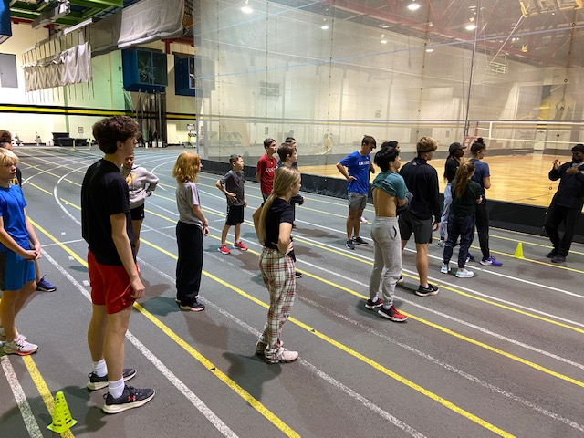
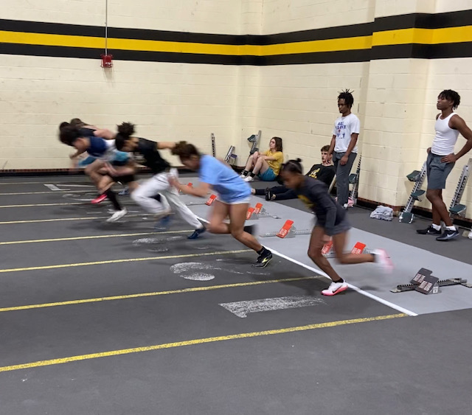
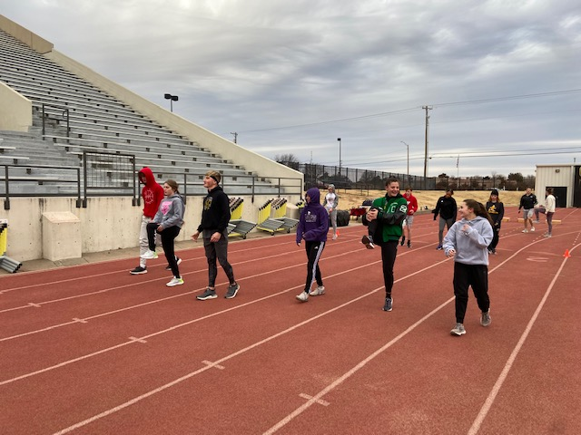

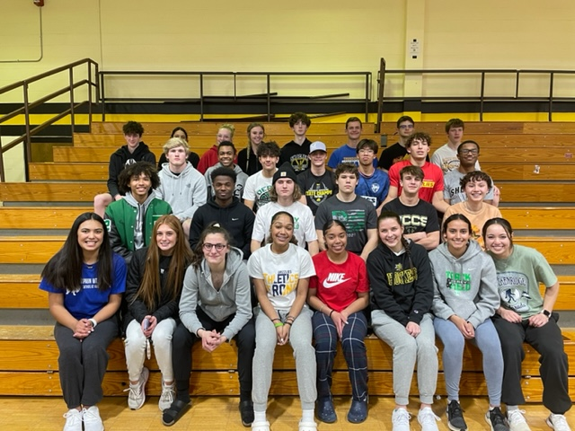



Mission and Vision
The Shocker Track Club Youth Team operates under the auspices of the Shocker Track Club Board of Directors. Separate indoor and outdoor seasons provide opportunities for multiple months of training. Support is also provided for high school athletes interested in competing at the collegiate level. Meetings can be scheduled with parents/athletes to discuss the collegiate eligibility and recruiting process.

The Mission of the Shocker Track Club Youth Team is to provide opportunities for youth to train and develop in track and field, from an introductory level to high-level competition, under the framework of USATF guidelines.

Shocker Track Club

www.ShockerTrackClub.com

Youth Team

General Program Information Only
Contact us for Complete Details

Ages 9 through 18

#STCFamily

Indoor 2026 - 2027
Parents
Parents are important to the success of the athlete and the track club’s activities. We thus ask the parents to observe the following:
- Maintain a positive attitude and pay all fees in a timely manner.
- Understand that once an athlete is at a given facility, they are under the supervision/jurisdiction/guidelines of the STC Youth Team management and coaching staff.
- Remain in the seating area at practices and meets.
- Ask questions of STC Youth management and coaches at an appropriate time and in an appropriate manner.
- Consider volunteering or joining our Open or Masters Teams!


Practices
Track & Field practices are held on the Wichita State University campus in multiple facilities that we rent for our use. Three to four practices are typically scheduled weekly between October and February, with optional practices available for detail work.
Track Meets
Participating in Track Meets is optional and at the expense of parents unless stated otherwise. Some travel is required. At least four meets are intended for all ages of youth athletes, with others designated for high school athletes only. A complete list of Track Meets will be published when complete. A USATF membership is REQUIRED for athletes competing in meets.
Registration Fees
The Joiner Registration Fee is $165 for the first month of participation. Additional fees are $30 for participating in each additional month, and may be combined to increase the initial Joiner Registration Fee. See the Youth Operations Director for complete and specific information. The Registration Joiner Fee includes two STC team t-shirts, a gear-bag, and free participation in the STC Youth Indoor Youth Meets.
Staying Informed
Weekly newsletters are issued to parents of registered children.
The Indoor Training Program
The Indoor Program training begins on October 1, 2026, lasting through February 25, 2027. Coaching for Youth athletes ages 9 through 18 is provided in every indoor practice.

Coaches
All STC Youth Coaches AND Leaders are USATF members, have passed the USATF/NCSI background check, and completed the USOC SafeSport training. All Coaches have competition experience, with some having NCAA, NAIA, and post-collegiate experience. Some are USATF Level 1 and/or Level 2 Coch Certified. Coaches “deliver” proven practice and workout strategies developed through various experiences, research, and collaboration with universities and professional organizations.

Program Management
The Shocker Track Club Youth Team is a USATF Member Club managed by a Director, with assistance from the Youth Operations Director and Head Event Coaches. They are responsible for planning and leading all activities, including: team organization, training activities for athletes and coaches, overall training template, oversight of membership activities, and co-direction of any STC Youth home meets. STC is the only local youth track club that provides nearly year-round coaching in every event with connections to NCAA D1 & NAIA universities.

  - 1845 Fairmount, Campus Box 18
  - Wichita, Kansas 67260
  - (316) 993-6824
  - youth@shockertrackclub.com
  - youthoperations@shockertrackclub.com

The Shocker Track Club (STC) is a 501(C)(3) organization that facilitates Wichita area Track and Field activities.
STC MISSION

LEADERSHIP

YOUTH PROGRAMS

