
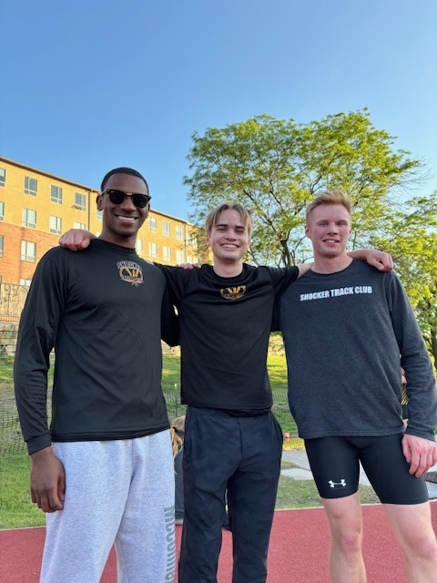
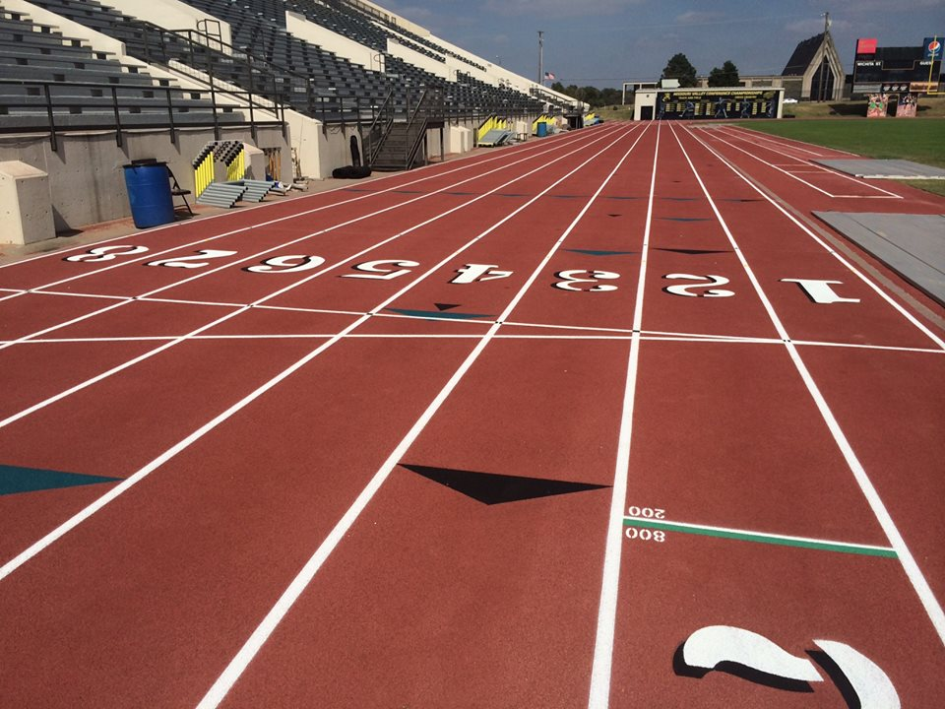




USATF Affiliation
The Shocker Track Club is affiliated with USA Track & Field through the Missouri Valley Association. USATF Membership is REQUIRED for Shocker Track Club Open Team members planning to compete in meets. Details are available at www.USATF.org.
Organization and Mission
The Shocker Track Club Open Team is for adult athletes up to the age of 30 and operates under the auspices of the Shocker Track Club Board of Directors. Separate indoor and outdoor seasons provide opportunities for nearly year-round training.

The Mission of the Shocker Track Club Open Team is to provide training and/or competition opportunities for: (a) current college students not competing for their university, (b) post-collegiate athletes, and (c) other athletes under the framework of USATF guidelines.

Leadership Meetings
Open Team membership meetings are held annually. Watch www.ShockerTrackClub.com for details.

Shocker Track Club

ShockerTrackClub.com
  - Open Team

2025 - 2026
  - 1845 Fairmount
  - Wichita, Kansas 67260
  - (316) 993-6824
  - president@shockertrackclub.com

Practice and Training Opportunities
Practices are typically held on the Wichita State University campus, with outdoor practices at Cessna Stadium, and indoor practices at the Heskett Center. Practice times are typically in the evenings between approximately 615p and 800p. Outdoor practices are typically held in late March through July, and September. Indoor practices are typically held in October through mid-March.
Track Club Youth Track and Field Team trains. Pole Vault training is available between October and February and June and July

Apparel
Open Team membership includes two (2) shirts*, one (1) crew-neck sweatshirt, and one (1) gear bag. Occasionally other STC accessories (e.g., beanie caps, ball caps, wristbands, etc.) are provided if available.
* Shirt choices include - (a) black jersey, (b) SS black t-shirt, (c) LS black t-shirt, or (d) SS black sleeveless t-shirt.

Competition Opportunities
3) Free participation in open competition approved indoor and Outdoor meets hosted by Wichita State University and Friends University.
- Shocker Track Club Indoor or Outdoor meets for adults
- Other Indoor or Outdoor meets as available and appropriate.

Athlete Eligibility
Eligible athletes are young adults between the ages of 18 and 30 that are – (a) Out of high school, (b) a current college student not competing for their university, or (c) post-collegiate athletes, or (d) other athletes. Training and competition opportunities are provided within Shocker Track Club and USATF applicable rules guidelines. An application is required.

Team Director
The Shocker Track Club Open team is managed by the Director of the Open Team who is responsible for managing membership information and planning training activities for athletes. Contact Darren Muci at president@shockertrackclub.com with questions

Membership
$100 or $150. This is a one-time annual membership fee that is not pro-rated team benefits and amenities are provided for:
- Indoor Training - October through March
- Outdoor Training – April through July and September

Membership includes:
(1) Practice and Training Opportunities at designated times and locations. Organized practices are typically held during practices with the Shocker Track Club Youth Team as most STC Coaches are available at those times and locations. Access to certain work-out facilities in the Heskett Center are occasionally available.
(2) Apparel
(3) Competition Opportunities

MEMBERSHIP and COACHING

LEADERSHIP and MEMBERSHIP
The Shocker Track Club (STC) is a 501(C)(3) organization that helps support Wichita area Track and Field and Cross-Country activities.
STC MISSION

