

S A V E T H E D A T E

SHOCKER TRACK CLUB

2016 Summer Jumps Fest

**Saturday, June 18, 2016**

**Wichita State University Cessna Stadium**

**Wichita, Kansas**



USA Track & Field Sanctioned

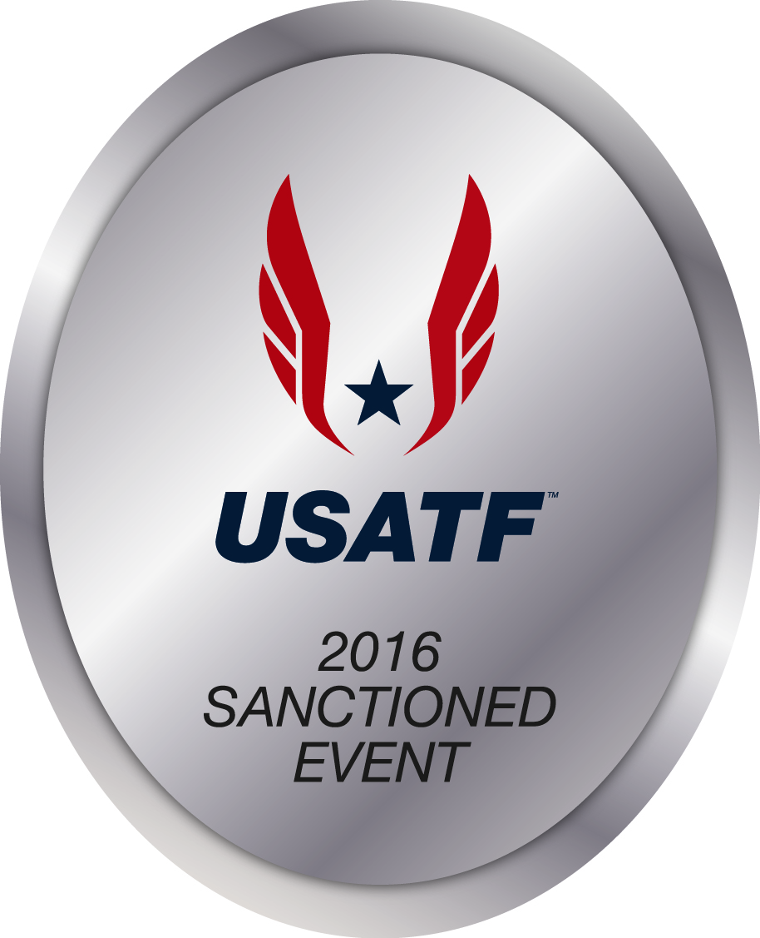

|  |  |
| --- | --- |
| **POLE VAULT** | **HIGH JUMP** |
| Two Pits! | Two Pits! |
| Youth Girls and Youth Boys | |
| Open Women and Open Men | |
| Elite Women and Elite Men | |

**Details Available Soon at**

[**www.STCJumpsFest.com**](http://www.ShockerTrackClub.com)