

Event Manual

2014 Indoor Track & Field Championships

Ahearn Field House

Kansas State University

Dates:

Friday, February 7

Saturday, February 8

This manual was comprised using information from the NAIA & [KCAC Sport Guidelines](http://www.kcacsports.com/d/Sport_Guidelines/Track_and_Field_Guidelines.pdf) for Men’s and Women’s Indoor Track & Field.

Table of Contents

|  |  |
| --- | --- |
| Admission | 3 |
| Apparel | 3 |
| Athletic Training | 3 |
| Awards | 3 |
| Coaches Meeting | 4 |
| Contact Information | 4 |
| Entries | 5 |
| Events / Schedule of Events | 5 |
| Equipment | 5 |
| Games Committee | 6 |
| Fan Seating | 6 |
| Hospitality | 6 |
| Meet Director | 6 |
| Meet Expenses | 6 |
| Numbering | 7 |
| Officials/Judges | 7 |
| Parking | 7 |
| Preferred Lanes | 8 |
| Results | 8 |
| Scoring | 8 |
| Signage | 8 |
| Team Area | 8 |
| Timing System | 8 |
| Workers Needed | 9 |
| Future Considerations | 9 |
| Ahearn Field House | 9 |

Admission

* Pricing - Daily
  + $8 - Adults
  + $3 - Students, Children 6 – 18 (College students must show ID)
  + $5 - Senior (55 & Up)
  + Free – Children 5 & Under

Apparel

* Pre-sale information will be available through Mr. Tee
* Sales will also be on site

Athletic Training

* KCAC will provide two Athletic Trainers.
  + Schools are required to bring their own athletic training supplies and equipment
  + There will be a designated Athletic Training area at the meet
  + Proper documentation must be provided for student athletes to receive modalities/treatments
    - i.e. Ultrasound, etc…

Awards

* All-KCAC
  + The top three finishers in each event, including relays, are designated as All-KCAC.
    - The top three finishers in each event are awarded KCAC medals
  + Fourth through sixth place finishers are designated All‐KCAC Honorable Mention.
* Team plaques are awarded to the men’s and women’s championship teams at the end of the meet
* The KCAC Indoor Track & Field Coach of the Year for both men and women will be selected by a vote of the head coaches.
* The Women’s and Men’s high point scorers will be presented KCAC Indoor Track & Field Athletes of the Year Plaques following the final event.
  + Relay runners get credit for .25 of the points scored by the relay team.
* Presentation of Awards
  + Recognitions (3:05 p.m., Feb. 8th) – Champions of Character Student-Athletes
  + Completion of Events – Top place holders in events
  + Completion of Meet – Team, High Point, and Coach Awards
  + Podium – TBA
  + KCAC will bring Media Backdrop

Coaches Meeting

* TBA

Contact Information

|  |  |  |
| --- | --- | --- |
| **Indoor Track & Field Chair**   * + Jim Helmer | Office: 620-229-6217  Cell: 620-262-7606 | jim.helmer@sckans.edu |
| **Athletic Trainer**   * + Phil Schoenwetter | Office: 620-242-0584 | schoenwp@mcpherson.edu |
| **KCAC Assistant Commissioner/SID**   * + Robert Brennecke | Cell: 618-806-5766  Office: 316-337-5999 | brennecke@kcacsports.com |
| **KCAC Commissioner**   * + Scott Crawford | Cell: 316-425-3460 | scott.crawford@kcacsports.com |
| **Meet Announcer**   * Carol Swenson | Cell: 620-480-9914 | swensonc@mcpherson.edu |
| **Clerk**   * Mike Lynam |  | [mikelynam@gmail.com](mailto:mikelynam@gmail.com) |
| **Field Judges**   * Mike Holladay      * Jerry Proffitt * Keith Kraushaar * Darren Muci | 316-304-5744    316-613-9885  Office: 316-973-2048 | [holladay02@gmail.com](mailto:holladay02@gmail.com)  [ahollada@sedgwick.gov](mailto:ahollada@sedgwick.gov)  jerry.proffitt@cox.net  [kck2455@hotmail.com](mailto:kck2455@hotmail.com) |
| **Starters**   * Mark Isom      * Vic Everett | Home: 620-585-6789  Work: 620-241-9179 | [misom@ncra.coop](mailto:misom@ncra.coop) |
| **Kansas State**   * Kayla Oney   **Timing Crew**   * Marc Haught * Jess Herbig | 785-539-8763    Cell: 316-655-8929 | kayla@tryufm.org    mhaught@usd266.com  [jherbig@usd266.com](mailto:jherbig@usd266.com) |
| **Referee**   * Jim Krob |  | jkrob@fshu.edu |

Entries

* The entry deadline shall be 6:00 p.m. on Tuesday (February 4, 2014) prior to the meet.
* After the entry deadline all athletes must compete as entered or they will be disqualified from the meet
* No additions or substitutions are allowed after the confirmation/scratch deadline. Athletes must compete as entered or will be disqualified from the remainder of the meet. The honest effort will be enforced.
* A coach may enter up to six (6) participants per individual event.
* Heats and Scheduled events will be generated on Wednesday, February 5, 2014.
* Finalized Heats will be announced by Noon on Thursday, February 6, 2014.
  + Finalized heats will be delivered to the timing crew on the day of the meet.

Events / Schedule of Events

|  |  |  |  |  |  |
| --- | --- | --- | --- | --- | --- |
|  | **Friday, Feb. 7** |  |  | **Saturday, Feb. 8** |  |
| 5:30 | Long Jump | Women then Men | 11:00 | Shot Put | Men then Women |
| 5:30 | Weight Throw | Women then Men | 11:00 | Triple Jump | Women then Men |
| 5:30 | Pole Vault | Men then Women | 11:00 | High Jump | Men then Women |
| 7:00 | 4x800 Relay | Women then Men | 1:30 | Recognitions | - |
| 7:30 | 5000M | Women then Men | - | Distance Medley Relay | Women then Men |
|  |  |  | - | 60 M HH Prelims | Women then Men |
|  |  |  | - | 60 M Prelims | Women then Men |
|  |  |  | - | Mile Run | Women then Men |
|  |  |  | - | 60 M HH Finals | Women then Men |
|  |  |  | - | 60 M Finals | Women then Men |
|  |  |  | - | 400 M | Women then Men |
|  |  |  | - | 600 M | Women then Men |
|  |  |  | - | 800 M | Women then Men |
|  |  |  | - | 1000 M | Women then Men |
|  |  |  | - | 200 M | Women then Men |
|  |  |  | - | 3000 M | Women then Men |
|  |  |  | - | 4x400 Relay | Women then Men |

NOTE: All events will operate as finals, except for 60m Hurdles & 60m Dash.

Equipment

* Pits, Hurdles, and Standards are being rented through Kansas State University
* Teams need to provide their own weights, poles, batons, etc
* Implement weigh-in will be 30 minutes before field events start.

Games Committee

* The Games Committee shall consist of the Meet Director, the KCAC track and field chair, and one additional KCAC head coach selected in alphabetical order by institution. The Games Committee shall make decisions regarding meet procedures, rules violations, disqualifications, order of finish, and any other issues that may arise.
* The games committee will be: Jim Helmer, Kent Allshouse, & Damian Smithhisler

Fan Seating

* During field events fans may congregate in appropriate areas near those events.
* Fans are limited to the bleacher area during running events.

Hospitality

* A hospitality area will be available for coaches, staff, and volunteers

Meet Director

* The Meet Director shall be the head coach of the host school or a person from the host school designated by the head coach.
  + In the event the meet is hosted by the conference, the commissioner will act as meet director
* The Meet Director’s duties include the following:
  + Determine the time and location of the coaches meeting, and include this information in the mailing to coaches.
  + Arrange for, supervise, and instruct all meet help.
  + Arrange for FAT timing equipment.
  + Arrange for/schedule the starter.
  + Provide athletic trainers and arrange for emergency care if needed.
  + Arrange for presentation of awards following each event.
  + Supervise the presentation of Most Valuable Athlete plaques, Team Championship plaques, and Coach of the Year plaques immediately following the meet.

Meet Expenses

* Each KCAC institution sponsoring Track & Field will be assessed a $400 fee to help with costs associated with the Indoor Track & Field Championship Meet.
  + Conference members will equally share the cost of the inaugural event after gate fees and sport fees are applied.

Numbering

* Running numbers/hip numbers are to be secured through the HOST and are considered an event expense.
* Numbers will be distributed to runners upon race check-in

Officials/Judges

* The selection and assignment of championship meet officials is the responsibility of the HOST. The HOST shall provide certified officials and trained volunteers as deemed necessary by the HOST and KCAC.

Parking, Maps, & Directions

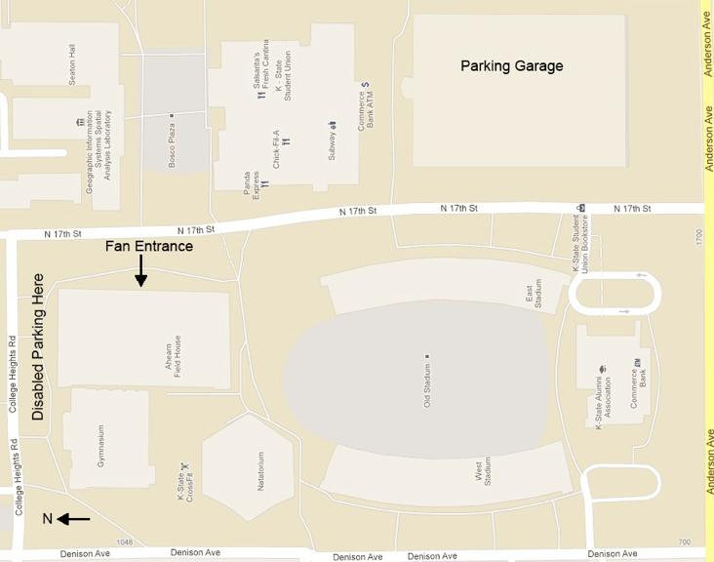

Preferred Lanes

* In running event preliminaries, preferred lanes should be assigned according to entry times. Prelim hears should be based on entry times. Heat order in the prelims should be random.
* In races that are finals only, preferred lanes should be assigned according to entry times. Heat order is slowest to fastest.

Results

* Overall results will be available online directly following the meet
* Printed results will be provided to head coaches
* KCAC Staff will upload meet results to KCACsports.com

Scoring

* The top six finishers in each event will score (10-8‐6‐4‐2‐1)

Signage

* KCAC Signage needs to be displayed

Team Area

* Teams will congregate on the west side of the seating area in the field house.

Timing System

* A fully automatic timing system and appropriate backup equipment must be provided at the championship facility.
* Marc Haught and Jess Herbig will implement the timing system.
* Live scoring will be available

Workers Needed

* Volunteers
  + 10 to 12 per day
  + Lap counting
  + Member schools volunteer groups

|  |  |  |
| --- | --- | --- |
| Event TIme | **Friday, Feb. 7** | Volunteers Recommended |
| 5:30 | Long Jump | 4 |
| 5:30 | Weight Throw | 3 |
| 5:30 | Pole Vault | 2 |
|  |  |  |
|  | **Saturday, Feb. 8** |  |
| 11:00 | Shot Put | 3 |
| 11:00 | Triple Jump | 4 |
| 11:00 | High Jump | 2-3 |

Future Considerations

* Post championship evaluation of competition site and facilities based upon feedback from KCAC coaches and student-athletes.
* Implementation of a sport specific banquet.

Ahearn Field House

* Site: <http://www.kstatesports.com/facilities/ahearn-fh-indoor-track.html>