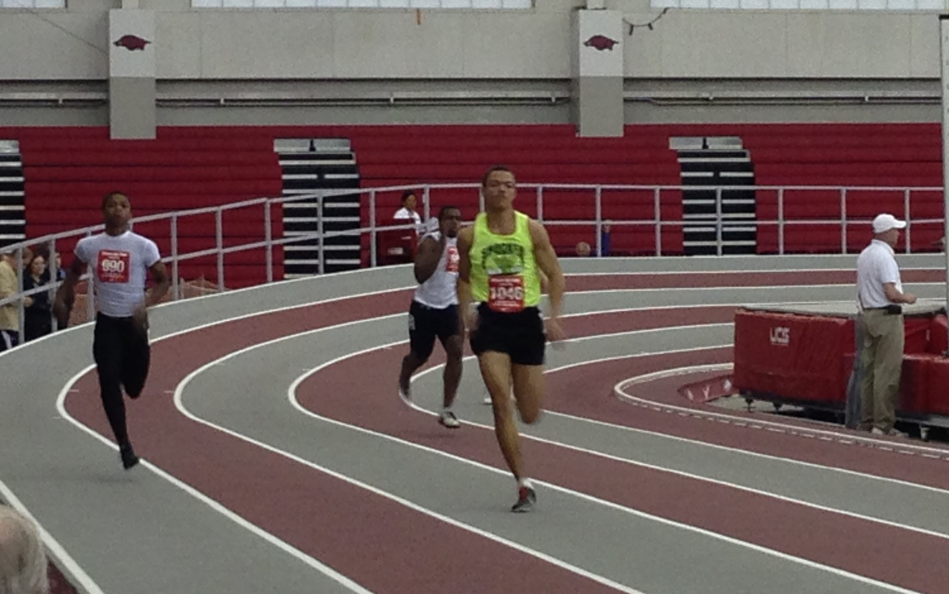  

Youth Team

# Parents

Parents are important to the success of the athlete and the track club and we ask the parents to observe the following:

* Consider volunteering!
* Maintain a positive attitude
* Pay all fees in a timely manner
* Realize that once an athlete is at a given facility, they are under the supervision/jurisdiction/guidelines of the STC Youth Team management and coaching staff
* Ensure that the athlete is at practice and at meets on time
* Remain in the seating area at practice and meets
* Ask questions of STC Youth management and coaches at an appropriate time and in an appropriate manner

#### ShockerTrackClub.com

The Shocker Track Club Youth Team operates under the auspices of the Shocker Track Club Board of Directors. Separate indoor and outdoor seasons provide opportunities for nearly eight months of training.

**The Mission of the Shocker Track Club Youth Team is to provide opportunities for youth to compete in track and field from an introductory level, to high-level competition, under the framework of USATF guidelines.**

# Mission and Vision

Shocker Track Club

Indoor 2015-2016

The fee for Pole Vault is $160; the fee for Sprints, Distance and Jumps is $100. All fees include a STC team shirt Meets at Cessna Stadium.

Practices begin November 3, 2015 and continue through February 2016. Pole Vault practices are held Tuesday and Thursday (630p to 830p) and Saturday (100p to 400p) at USD 259 Northeast Magnet High School, 5550 N. Lycee (east of 53rd Street and Rock Road) in Bel Aire, KS. Sprints, Distance and Jumps practices are held from 430p to 600p on Tuesday and Thursday at Wichita State University’s Heskett Center Track.

**Practices**

Fees

Separate indoor programs for Pole Vault, and Sprints, Distance and Jumps (High Jump and Long Jump) focus on instruction, training and competition-readiness. Along with warm-up, daily specific stretches and drills are conducted for all athletes.

### Coaches and Volunteers

All STC Youth Coaches AND key Volunteers are USATF members, and have passed a USA Track & Field background check. Coaches “deliver” strategies developed by the Wichita State University Track & Field Coaching staff.

Coaches are responsible for the day-to-day training, practices, meet day preparation and coaching, as well as relaying information pertaining to meet day entries to parents, etc. Volunteers can assist in the following areas:

Marketing // Practice facilitation // Home Meet Management and Support // Fundraising

Informational meetings are held regularly to provide information to parents. Watch ShockerTrackClub.com for details.

**Informational Meeting**

# Events

# 0

1845 Fairmount

Wichita, Kansas 67260-0018

(316) 978-5544

asstyouth@shockertrackclub.com

The Shocker Track Club (STC) is a 501(C)(3) organization that support s Wichita area Track and Field and Cross Country activities.

### Program Managers

A Director and Assistant Director, the Head Coach, and the Team Mom/Dad manage the Shocker Track Club Youth Team. They are responsible for planning and leading all activities, including: team organization, training activities for athletes and coaches, overall training template, oversight of membership activities, and co-direction of any STC Youth home meets.

STC MISSION

LEADERSHIP

YOUTH PROGRAMS