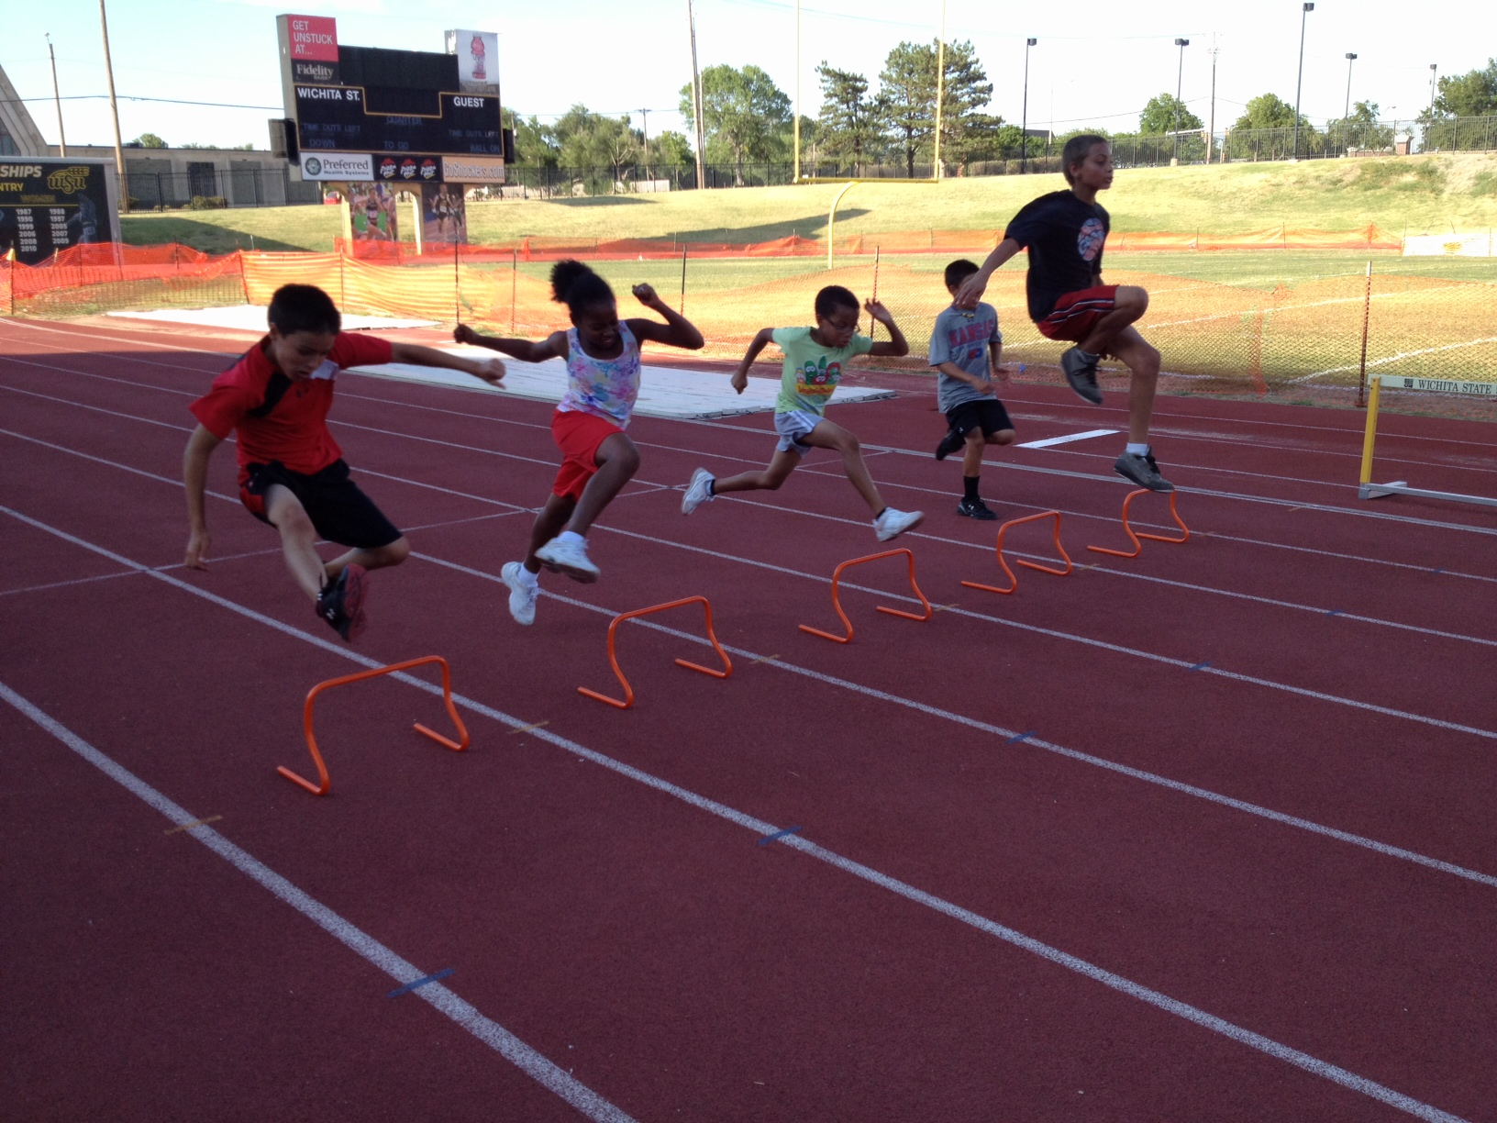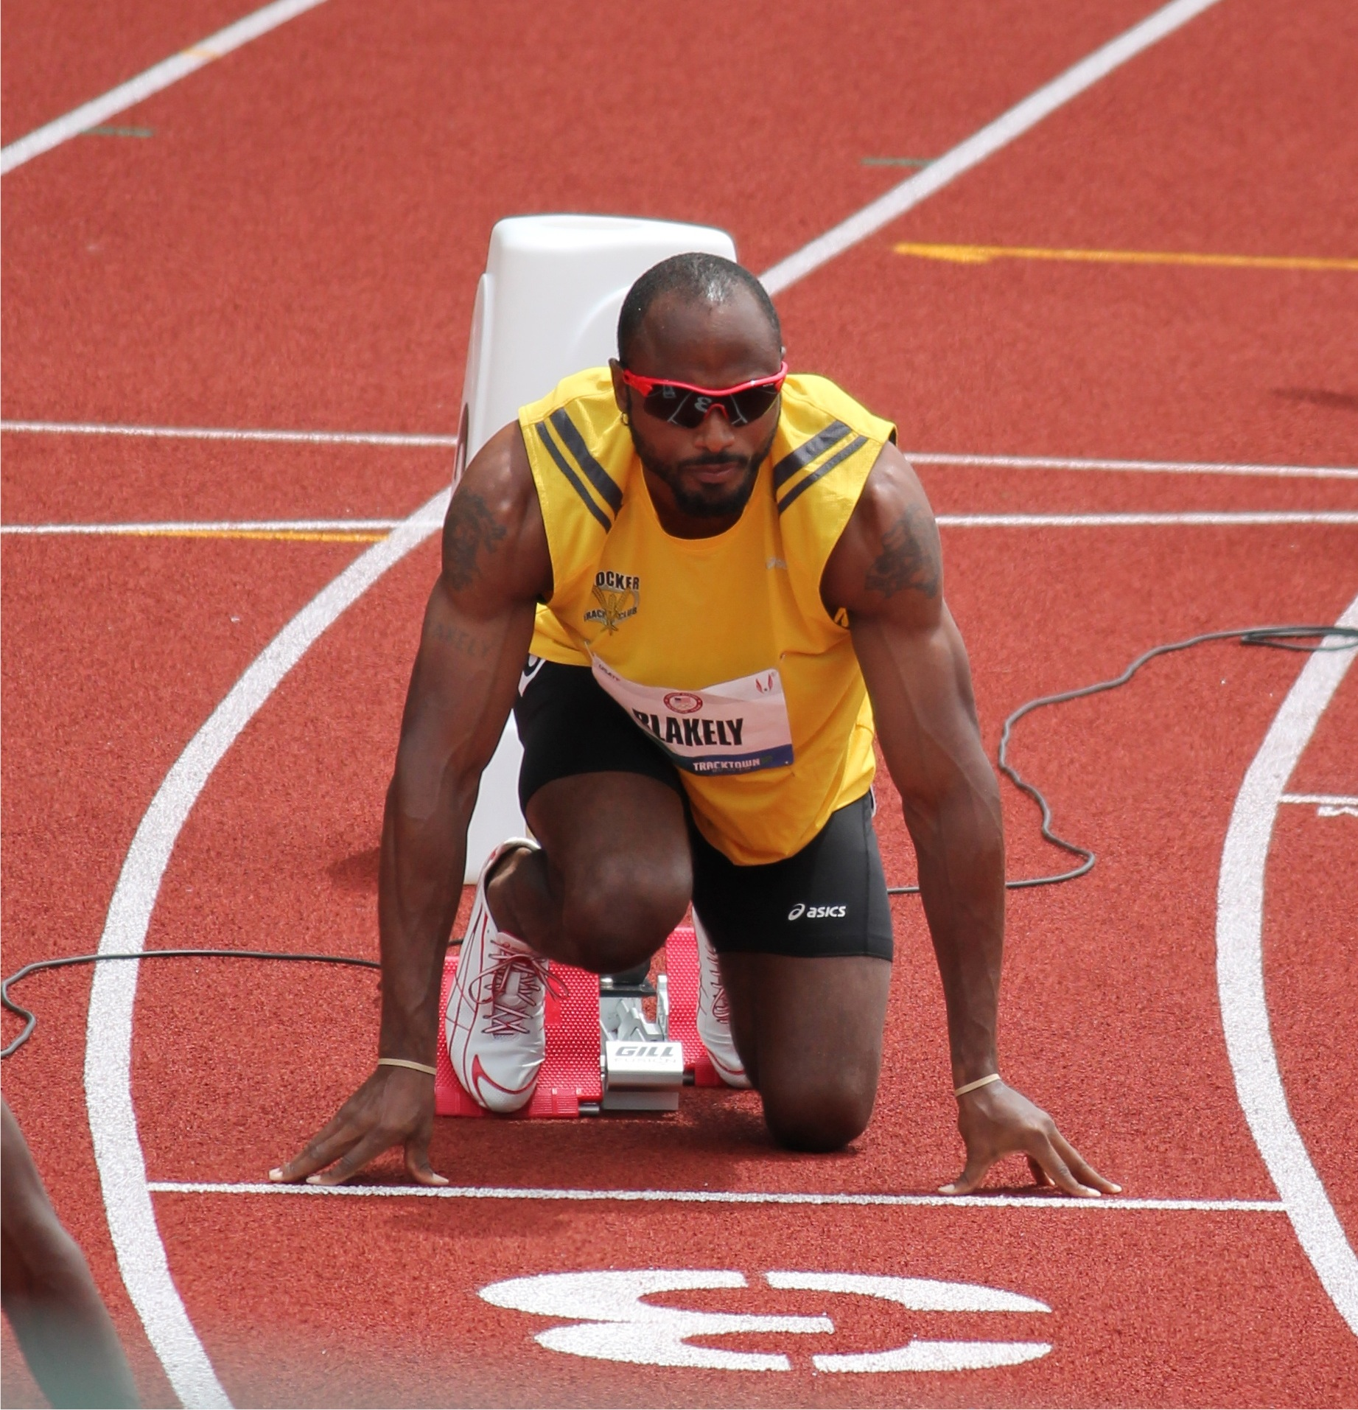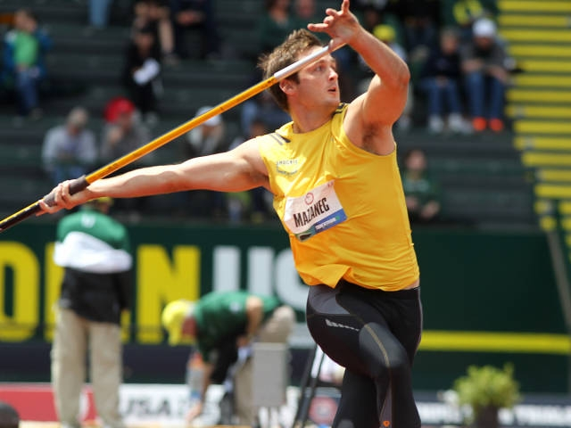 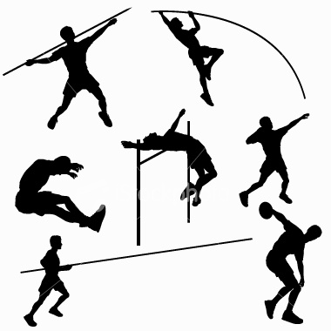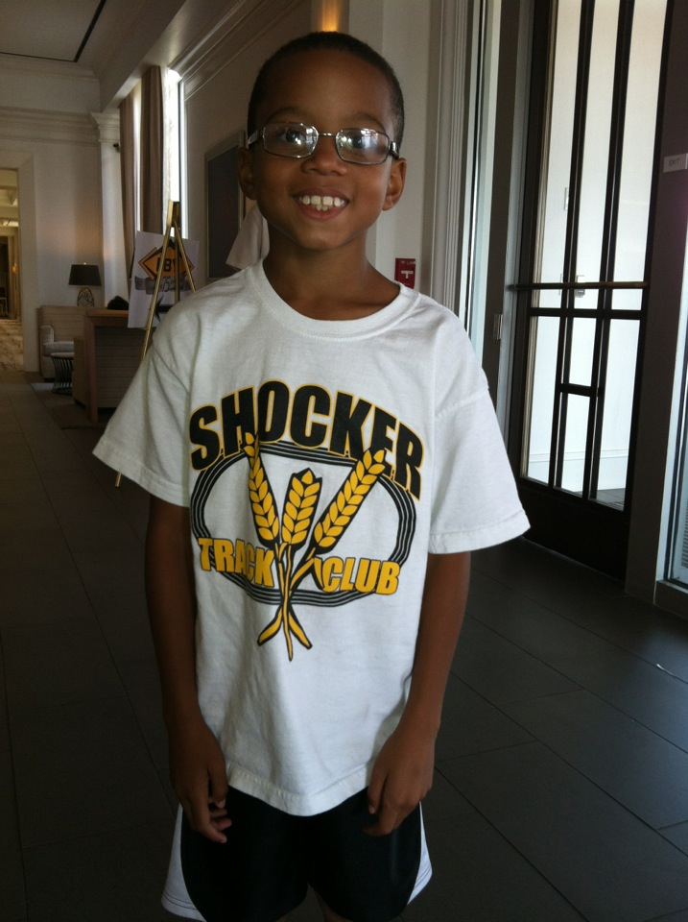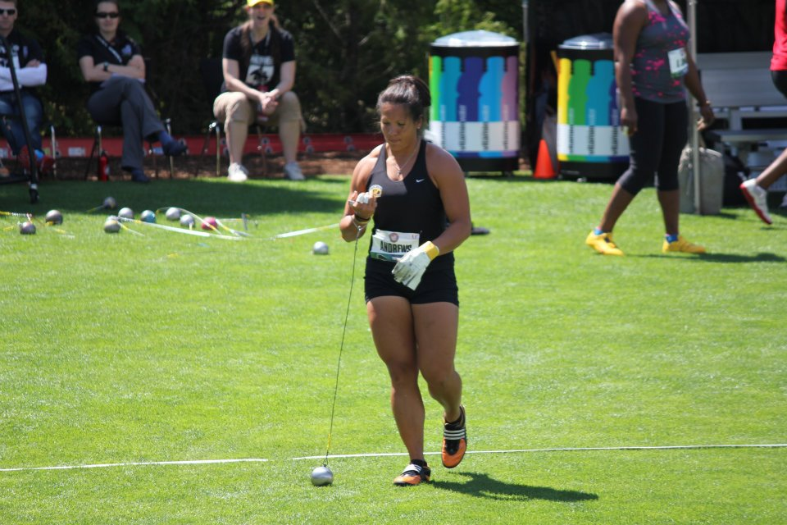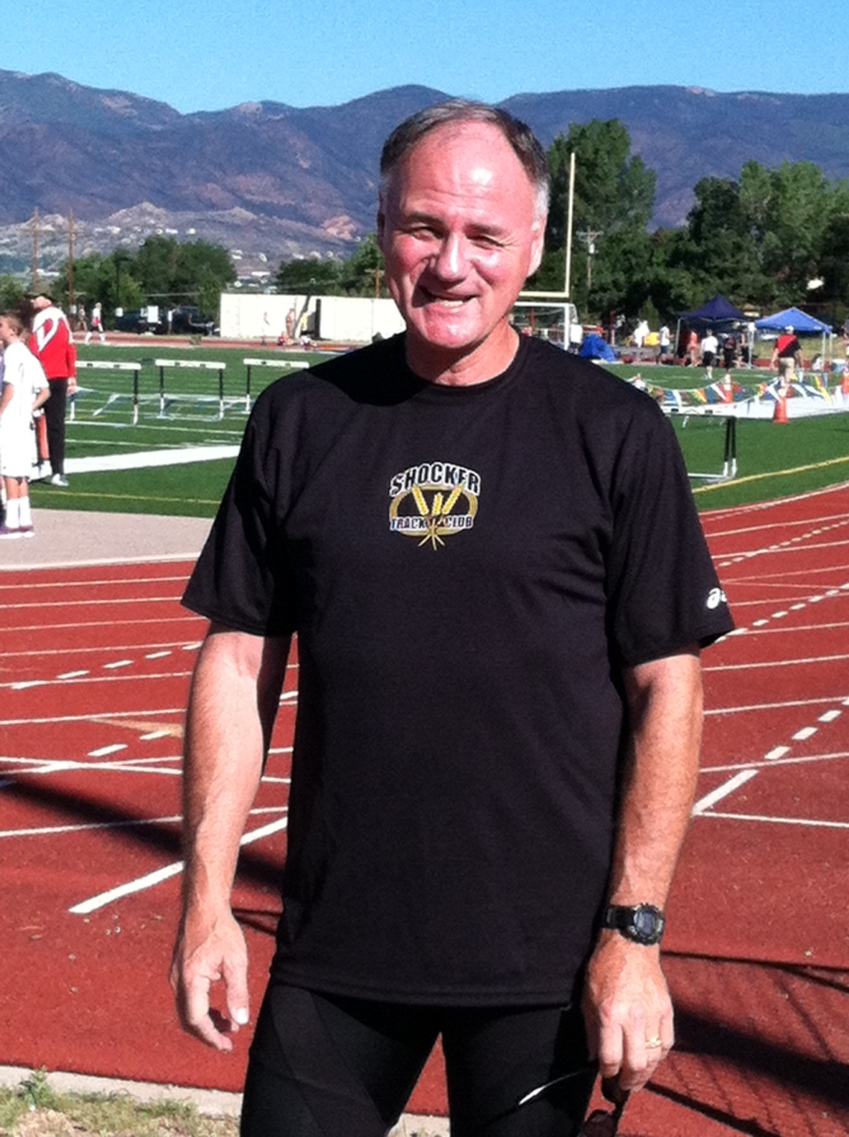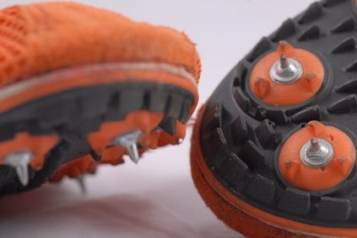

CORPORATE SPONSOR GUIDE

Uniforms

SHOCKER TRACK CLUB

* SHOCKER TRACK CLUB

2012

MISSION

The Shocker Track Club (STC) is an organization that helps support Wichita area Track and Field and Cross Country activities.

[www.shockertrackclub.com](http://www.shockertrackclub.com)

[State][Postal Code]

President Darren Muci

Vice President Chris Ellis

Treasurer Chandra Andrews

Secretary Joe Eby

Head WSU Track Coach Steve Rainbolt

Assistant WSU Track Coach John Wise

Chair, Officials/Volunteers Emily Green Maier

Chair, Memberships Sam Garrison

Chair, Elite Team Trent Mazanec

Chair, Masters/Open Team Larry Staton

Chair, Youth Team Patrick Simon

Chair, Futurist Laura Markuly

Chair, Uniforms and Gear Heidi Yost

Chair, Fundraising VACANT

Member Vic Everett

Member Mike Holladay

Member Bill Faflick

Member Keith Dome

Member George Nambo

Member RJ Brown

Member Joan Hearne

1845 Fairmount, Box 18

Wichita, KS 67260

(316) 978-5544

www.shockertrack.club

### Board of Directors

Organization

## ATHLETICS TEAMS

*Corporate donations to the Shocker Track Club provide uniforms and warm-up suits for Elite and Youth Team athletes, and valuable track rental time for practices.*

SPONSOR FEE PROVIDES –

* Team uniforms and Warm-up suits for Elite, and Youth Elite, Team Members.
* Team uniforms for Masters/Open Team Members
* Team t-shirt for all Elite, Youth, Youth-Elite, and Masters/Open Team Members.
* Track rental fees.

ANNUAL SPONSORSHIP FEE - $1500

SPONSOR FEE INCLUDES:

- Company Logo on STC Team T-shirt.

- 3’ x 5” Color banner displayed at all Shocker Track Club and WSU Track & Field and XC Events.

- Link on Shocker Track Club website.

- “LIKE” on your Facebook page if applicable.

- Public service announcement at meets.

- Listing in WSU T&F and XC, and STC programs

- Two (2) FREE admissions to WSU Track, XC, and STC events

- Shocker Track Club gear:

- Two (2) Ball Caps

- Two (2) T-shirts

- T-Shirt

- STC Window decal

# UNIFORM SPONSOR PROGRAM

ELITE TEAM

The Shocker Track Club Elite team supports post-collegiate athletics in their continuing endeavors. Three athletes competed at the 2012 Olympic Trials in Eugene, Oregon: Fernada Blakely (200m), Chandra Andrews (Hammer), and Trent Mazanec (Javelin). Darius Draudvila (Decathlon) will represent Lithuania at the London Olympics.

YOUTH TEAM

Youth from ages 6 to 18 receive appropriate instruction and coaching from USATF certified coaches and other volunteers. Membership fees vary. All fees include a t-shirt and practice time at WSU’s Cessna Stadium Track.

MASTERS/OPEN TEAM

Post-collegiate, and Master’s athletes, can continue to compete in open and Master’s meets throughout the year.

- Attribution

Shocker Track Club, Inc., is a 501©(3), non-profit organization. Your donation, less any benefits, is tax deductible.